

GreenCircle Certified Database

API Design Document

Executive Summary

This proposal outlines a comprehensive plan to expand your current database and develop a custom front-end solution to replace the existing Ecomedes platform. The project aims to address customer demands for more detailed data management, improve user experience with enhanced certificate viewing, and establish secure integration with Amazon Climate Pledge Friendly program.

Anuki Consulting will leverage its expertise in database architecture, API development, and third-party integrations to deliver a scalable, cost-effective, and user-friendly solution. The project is planned for 14-18 weeks, with milestones focusing on database enhancements, API integrations, and front-end development. The estimated cost is $70,000, with phased payments aligned with project progress to ensure transparency and satisfaction.

Project Overview

The new solution will enhance the existing system by adding more comprehensive data fields, improving certificate management capabilities, and facilitating seamless integrations with third-party platforms. The project also includes developing a custom front-end interface to replace the costly and limited Ecomedes platform, offering more intuitive user experience.

Description of Services & Deliverables

The following section outlines the key services and deliverables that will be produced throughout the project.

Anuki Consulting will provide the following:

Phase | Services Provided | Deliverables
Requirements Gathering & Analysis | - Conducting detailed requirements gathering sessions.  - Analyzing existing workflows and finalizing project scope. | - Finalized project scope document.
Architectural Design | - Design the database architecture and API Integration.  - Define security considerations.  - Setup development and testing environments. | - Database and API design documentation.
Database Expansion | - Expand database schema to include new data fields.  - Implement data integrity and performance measures. | - Expanded database schema.  - Data integrity protocols.
API Development | - Develop API to facilitate data flow between the database and Amazon.  - Implement error handling, logging, and security features. | - Fully functional API.  - Error handling and logging mechanisms.  - Authentication and security protocols.
Testing & Validation | - Perform unit and integration testing.  - Resolve defects identified during testing. | - Test results and validation report.
Deployment & Configuration | - Deploy the solution to the production environment.  - Configuring the system to ensure optimal performance.  - Conducting post-deployment validation to ensure a successful rollout. | - Production deployment report.  - Post-deployment validation checklist.
Documentation | - Prepare system, database and API documentation.  - Create a deployment guide. | - System documentation.  - Deployment guide.

Timeline
The project is expected to be completed within a total duration of 14 to 18 weeks. This timeline is designed for each phase of the project.
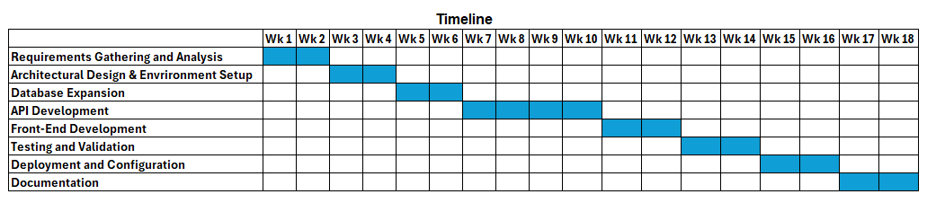
- Weeks 1-2: Requirements Gathering & Analysis—finalize scope and requirements.
- Weeks 3-4: Architectural Design—define system design, set up environments.
- Weeks 5-6: Database Expansion—integrate new data fields and ensure performance.
- Weeks 7-10: API Development—develop APIs for data flow, implement security.
- Weeks 11-12: Front-End Development—build and refine the custom front-end.
- Weeks 13-14: Testing & Validation—perform unit, integration, and user acceptance testing.
- Weeks 15-16: Deployment & Configuration—deploy to production, validate performance.
- Weeks 17-18: Documentation—prepare final documentation and training materials.

Fees and Payment Terms

The total cost for the database project is $70,000. The payment will be structured as follows:
- 30% Upfront Payment: A payment of $21,000 is required upfront before the commencement of the project. This will cover the initial phases, including requirements gathering, analysis, and architectural design.
- 40% Midway Payment: An additional $28,000 will be due upon completion of the API development phase, ensuring that database and front-end structures are in place.
- 30% Upon Completion: The remaining $21,000 will be due upon successful project delivery and post-deployment validation.
Please note that the estimate provided does not include hosting fees, monitoring, or ongoing maintenance costs. These services can be arranged at an additional cost if required.

Why Choose Anuki Consulting?
- Expertise and Experience: Our team of seasoned professionals brings a wealth of experience in implementing complex systems and ability to navigate issues, data management, AI integration, and automation.
- Customized Solutions: We tailor our services to meet your specific needs, ensuring that our solutions align with your business objectives.
- Commitment to Quality: We prioritize accuracy, efficiency, and user satisfaction in every project we undertake.
We appreciate the opportunity to present this proposal to you. At Anuki Consulting, our mission is to empower your business through innovative solutions. We are confident that our expertise and customized approach will significantly enhance your operational efficiency and support your strategic goals.

Our team is dedicated to the success of this project from start to finish. We are committed to delivering a solution that not only meets your immediate needs but also provides a solid foundation for future growth and innovation.

We look forward to the possibility of working with you and contributing to your ongoing success. If you have questions or need further information, please contact us.

Thank you for considering Anuki Consulting as your partner in this important initiative. We are excited about the potential to collaborate and drive meaningful improvements in your data management processes.

Sincerely,
Shawn West
Vice President
Anuki Consulting

IN WITNESS WHEREOF, the parties hereto have executed this proposal as of the date last written below.

Acknowledgment
I hereby acknowledge that I have read, understood, and agree to the terms and conditions outlined in this proposal.

Approval
By signing this proposal, the client authorizes Anuki Consulting to proceed with the project as outlined and agrees to the payment terms specified.

Client Information
GreenCircle Certified, LLC
Name: Julie Golden
Title: Vice President of Marketing
Signature: __________________________
Date: __________________________

Consultant Information
ANUKI CONSULTING, LLC
Name: Shawn West
Title: Vice President
Signature: __________________________
Date: __________________________

